Expt_04_D15B Internet Security Lab Roll No:37



Experiment 13

Aim:

Study of malicious software using tools: Keylogger attack using a keylogger tool.

| Roll No. | 37 |
| --- | --- |
| Name | Mikil Lalwani |
| Class | D15-B |
| Subject | Internet Security Lab |
| LO Mapped | LO5: Use open-source tools to scan the network for  vulnerabilities and simulate attacks. |

**Aim -**

Study of malicious software using tools: Keylogger attack using a keylogger tool.

**Theory-**

Short for “keystroke logging,” a keylogger is a type of malicious software that records every keystroke you make on your computer. Keyloggers are a type of spyware — malware designed to spy on victims. Because they can capture everything you type, keyloggers are one of the most invasive forms of malware.

There are two main types of keyloggers: software and hardware. Keylogger software is more common than keylogger hardware because the latter requires actual physical access to a device.

**Screenshot-**

1. Go to the Kidlogger website and install the software. Also register with the site.

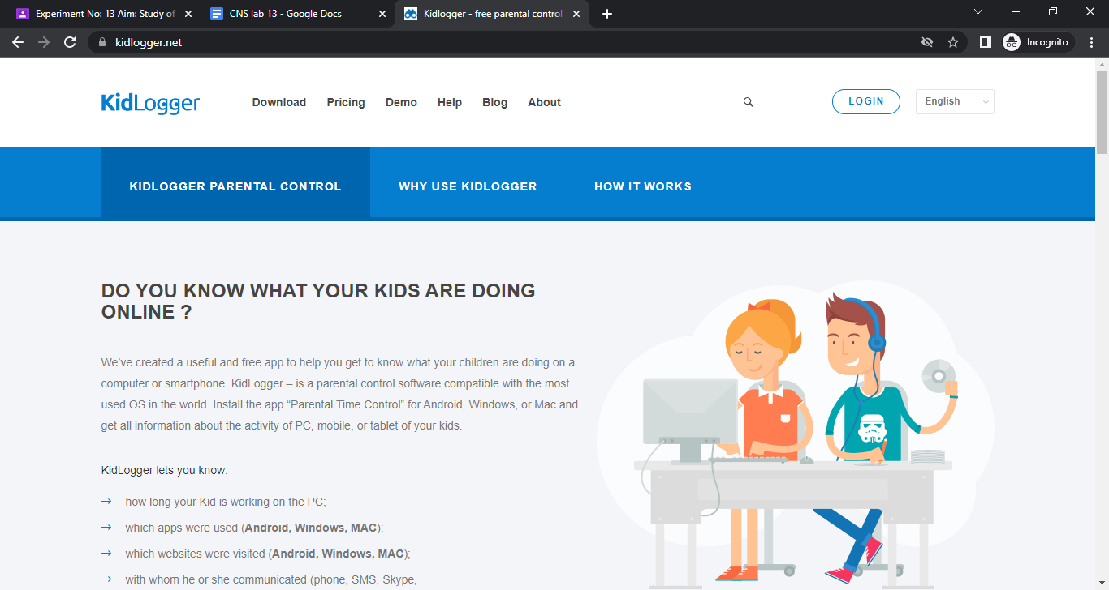

1. Download the software by entering the captcha.

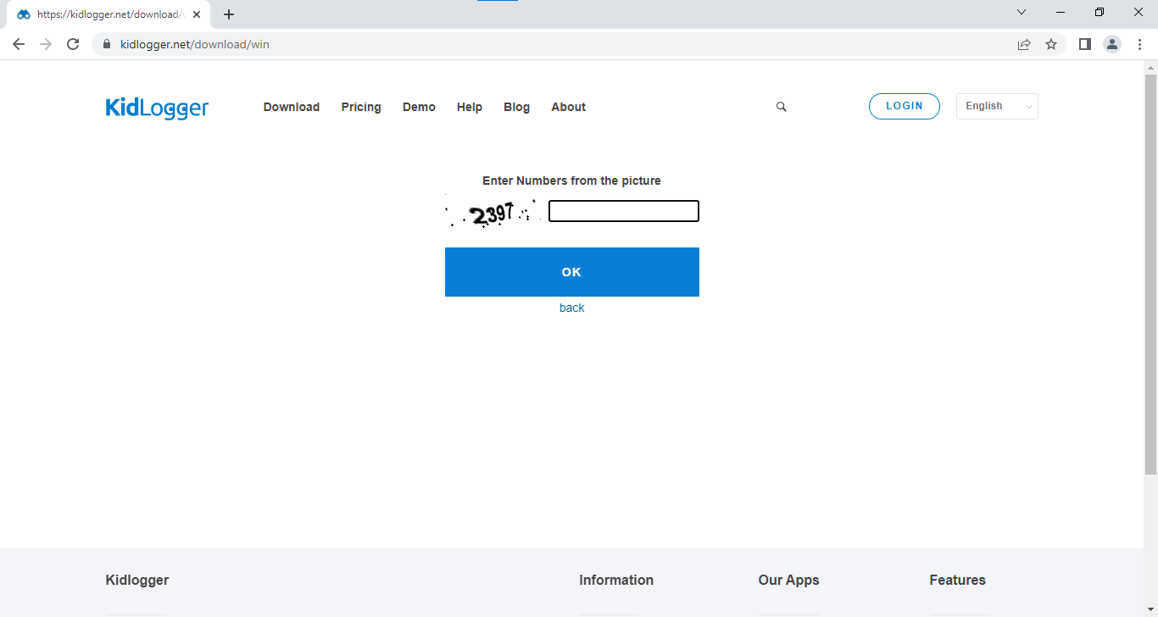

1. Install the software.

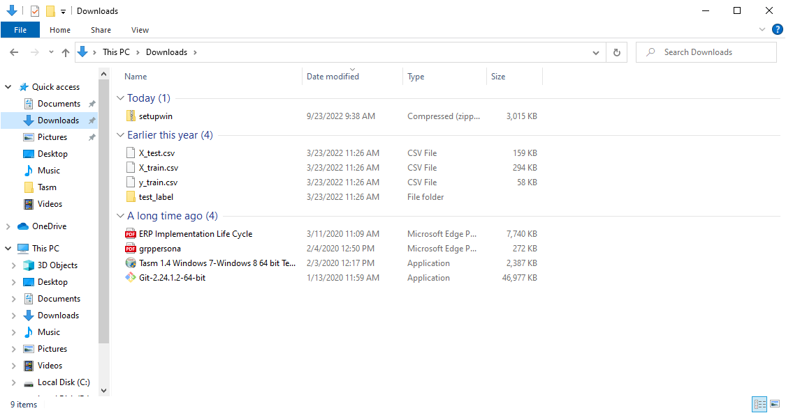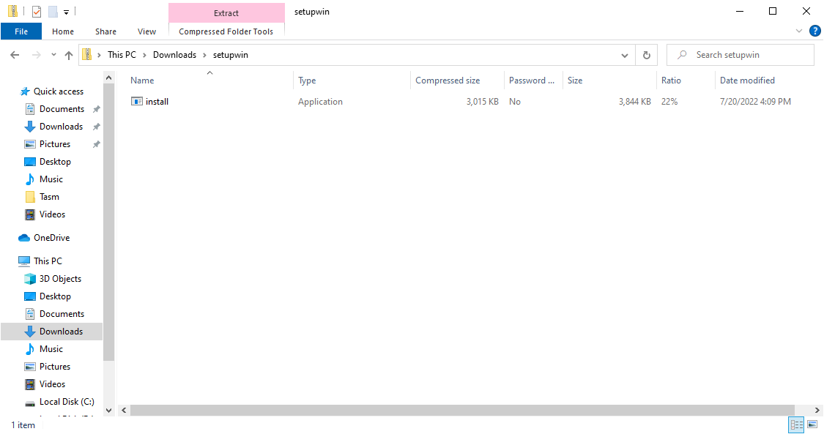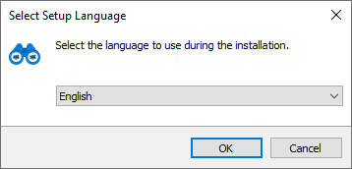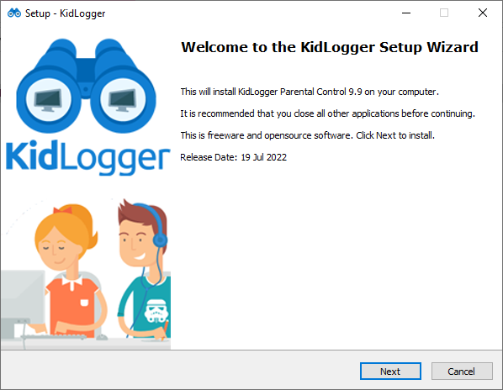

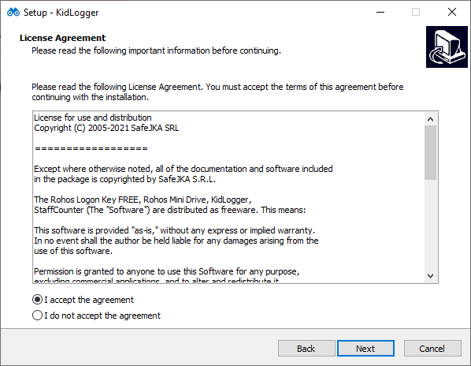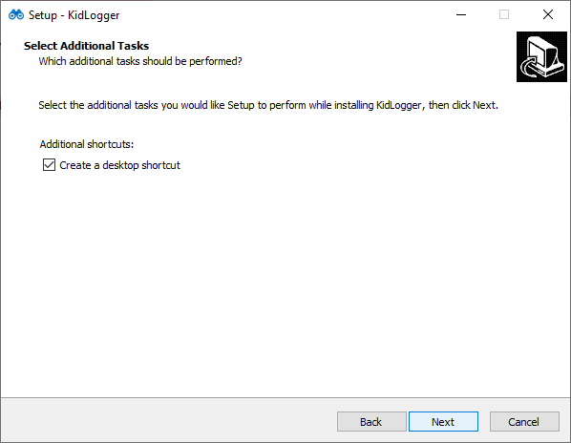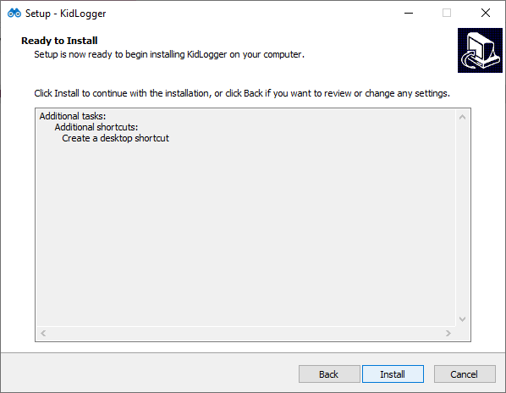



1. Click on “Connect to Kidlogger .net account”.

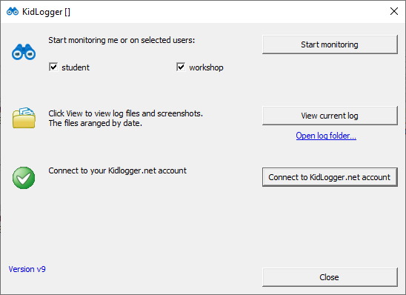

1. Enter the mail id you used to register earlier and click on connect.

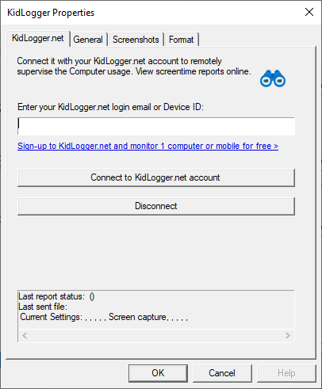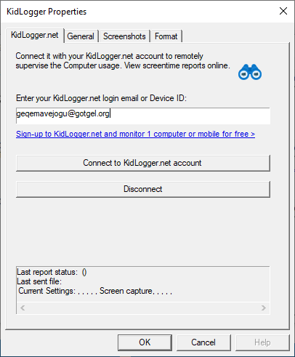

1. Login to your account on KidLogger and click on “View Logs”.

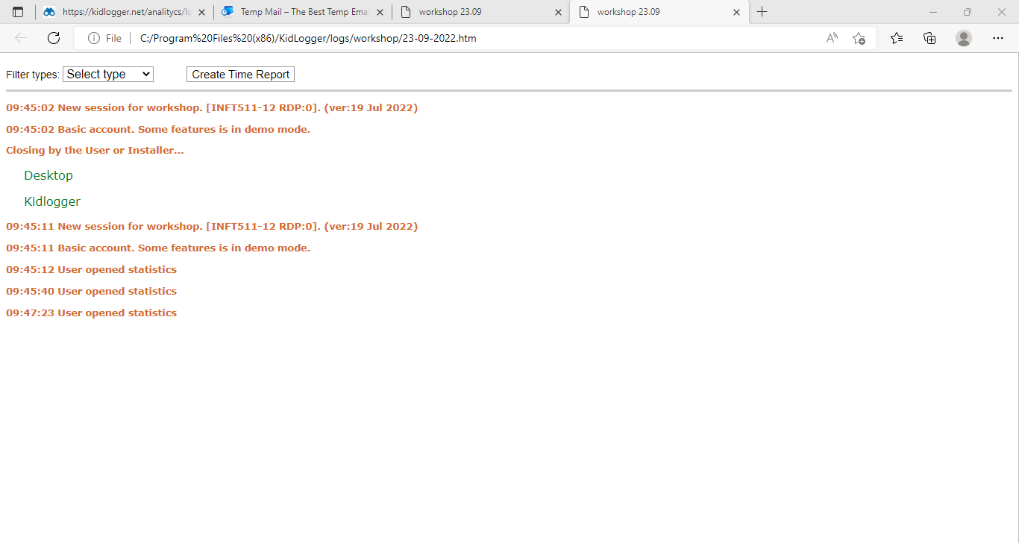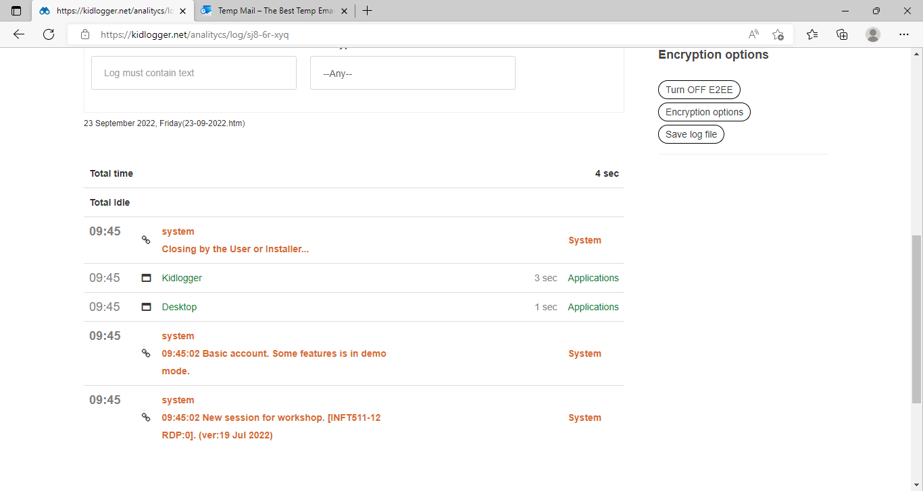

**Conclusion-**

We have successfully used KidLogger for key logging.